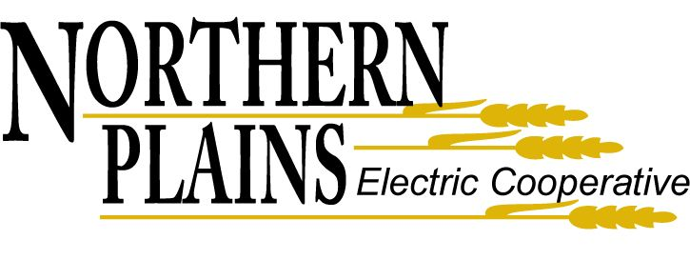
OPERATIONS MANAGER
Northern Plains Electric Cooperative Carrington, ND

Purpose
The Operations Manager shall be responsible for all electrical distribution operations, construction and maintenance functions of the Cooperative; including, but not limited to, management of the Operations Department. This position description is not intended to be an all-inclusive list of job responsibilities and requirements.

Responsibilities
Within the limits of approved board policies, operating guides and procedures, approved work plans and budgets and specific delegation from the General Manager, the Operations Manager assumes the responsibility for the following activities while developing and maintaining a favorable Cooperative image.

Supervisory
- Maintains responsibility and authority in directing the activities of all assigned personnel.
- Trains, develops and guides employees in job duties.
- Approves vacation, sick leave and overtime for department personnel. Reviews and signs time sheets. Monitors attendance and overtime records to identify problems and takes corrective action as needed.
- Ensure appropriate paperwork, records and reports such as staking sheets and material sheets are completed accurately and in a timely manner.
- Recommends the hiring, transfer, promotion, termination or disciplinary action of line personnel in cooperation with Human Resources and General Manager, to assure effective and efficient utilization of available resources.
- Completes performance appraisal and merit reviews for direct reports. Meets periodically with direct reports to discuss their performance.

Operations
- Secures and schedules personnel, equipment and materials to accomplish work in a timely manner.
- Monitors progress and costs for construction and system improvement projects to ensure that line crews are operating as efficiently as possible and within budget.
- Sees that all trouble calls receive prompt action. Directs personnel and equipment and coordinates work activities during system outages and/or abnormalities.
- Manage contractors to verify they are completing work efficiently and following the cooperative safety and construction guidelines.
- Makes transportation fleet purchasing recommendations and budgets.
- Coordinates the maintenance and preventative maintenance of assigned vehicles and work equipment so that transportation fleet is operated safely and economically.
- Manage necessary tools, equipment and material inventory to ensure they are properly maintained.
- Have a working knowledge of all substation switching operations, system apparatus or devices.
- Communicates with Central Power Electric Cooperative and associated utilities concerning load transfer, planned and unplanned outages, and work conditions.
- Maintains a current knowledge and understanding of RUS, NESC, Cooperative Safety Manual and other applicable standards and regulations to ensure that the Cooperative's distribution facilities are constructed and operated in a safe and efficient manner, consistent with these standards.
- Recommend improvements that can be made in operations, policies and procedures, or safety.
- Maintains necessary records of pole inspection, line patrol, and maintenance programs.
- Reviews periodically the results of the maintenance programs and recommends improvements where necessary.
- Receives and analyzes service interruption (outage) reports and voltage complaints for planning of system maintenance.
- Assists in the management and operation of the SCADA (Supervisory Control and Data Acquisition) system.

Safety
- Manage the Cooperative’s safety program and ensure safety is held to the highest priority.
- Ensure employees are trained in and familiar with the safety related work practices, safety procedures and other safety requirements in the cooperative’s safety manual.
- Develop and encourage good safe working habits and conditions for all Cooperative employees.
- Inspect work activities at job sites for efficiency, safety and compliance to regulations
- Oversees programs for the periodic testing of rubber gloves, hoses, shields, blankets, and other safety equipment to ensure safety standards are maintained.
- Investigates accidents, determines cause and takes corrective action to eliminate future occurrences.
- Ensure office, shop, and warehouse spaces and all equipment to be maintained in a safe, neat and orderly manner.

Culture
- Communicates and interprets the Cooperative's Mission Statement, strategic goals and policies to establish direction and to obtain understanding and commitment by the employees.
- Administers employee development consistent with applicable policies, procedures and practices to assure the maintenance of a highly competent, motivated and effective work force.
- To encourage and help maintain a high standard of morale among employees by assisting in the creation and maintenance of team spirit, cooperation, and enthusiasm throughout the Cooperative.
- Demonstrates a positive work ethic and sets an example for other employees to follow in teamwork, service excellence and job safety.
- Sees that work for department is planned and executed to ensure the highest possible customer satisfaction.

Physical Demands
- Work performed is primarily indoors with the requirement of some outdoor work. Indoors work is typically performed in the office sitting at a desk or table. Work performed outdoors may include exposure to varying temperature conditions including cold below 32 degrees and heat above 100 degrees.
- Medium work requiring exertion of up to 50 pounds of force occasionally and/or up to 20 pounds of force more frequently. Lifting and carrying of 10 to 50 pounds occasionally and up to 75 pounds rarely.
- Includes exposure to mechanical hazards, electrical burns, confined space and operating machinery.

Qualification Requirements
The applicant must meet the minimum requirements listed below to be considered.
- Minimum 10 years of industry related operations and/or engineering work required.
- Valid driver’s license and ability to obtain a Commercial driver’s license.
- Advanced computer skills and technical skills.
- Excellent communication skills.
- Excellent human relations and management of projects and people.
- Working Knowledge of RUS specifications and the NESC.
- Proficient with NISC software suite.

Phone: 1-800-882-2500 ● Email: justask@nplains.com
Northern Plains Electric Cooperative is an equal opportunity employer.

